|  |
| --- |
| gameli |
| Knight |
| COMP305 Assignment 01 |
| Version 1.4  All work Copyright © 2012 by XX Games.  All rights reserved. |
| **Jeff Li** |
|  |

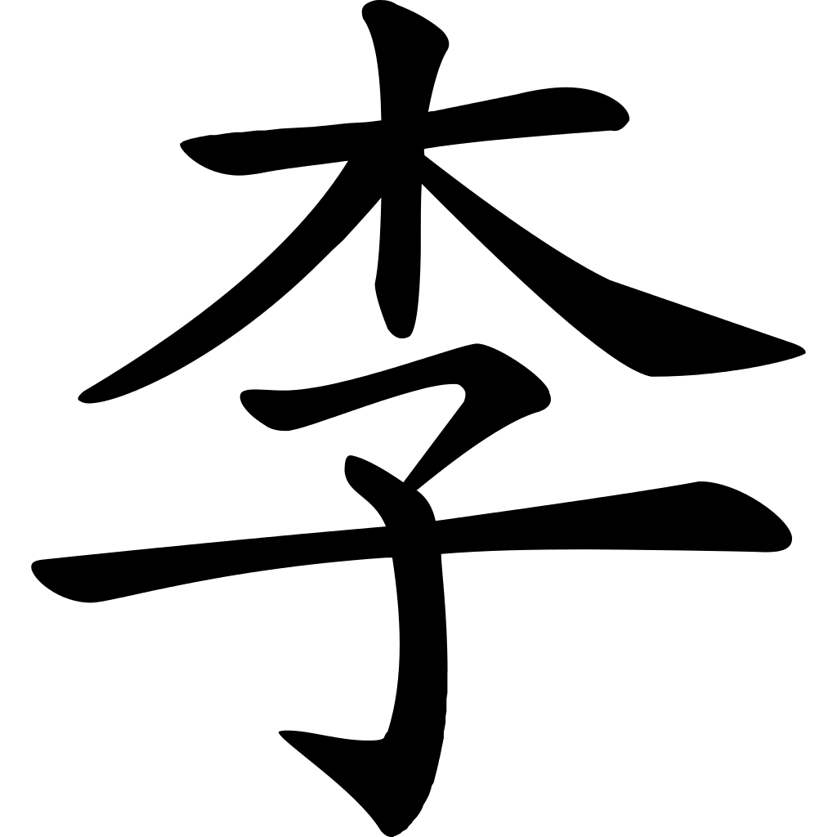

|  |
| --- |
| Oct 26th 2015 |

**Table of Contents**

Version History – 3

Detailed Game Description - 4

Controls – 4

Interface Sketch – 4

Screen Descriptions – 5

Characters – 6

Enemies – 6

Scoring – 6

Bonuses - 6

Sound Index – 7

Art / Multimedia Index - 7

**Version History**

Versions according to GitHub commits in repository

<https://github.com/TheOneRed/Knight>

**Version 1**

* Collected environment sprites
* Bought character and enemy sprites
* No level made

**Version 2**

* Created character and enemy movement scripts
* Flip function needed to be fixed
* Character and enemy prefabs made with animations
  + Idle, walking, death, jump

**Version 3**

* Implemented pick-up
* Implemented background

**Version 4**

* Fixed enemy flip function

**Version 5**

* Created game level using “Tiled” and “Tiled2Unity”
* Implemented sounds for pick up, jump and back ground music
* Implemented pick up, lives and score system GUI
  + When player collides with blue crystal = 50 points
  + When player collides with green crystal = 250 points
  + When player collides with yellow crystal = 500 points
  + When player collides with red crystal = 1000 points
  + When player collides with enemy = lose one life
  + When player collides with boundary (off map) = lose 3 life

**Version 6**

* Created game level using “Tiled” and “Tiled2Unity”
* Added game over, restart, you win GUI
* Implemented finish line. Player can win or lose

1. **Game Overview**

A 2d platformer game. The goal of the game is to get as many points as possible before dying. The player can move left, right and can double jump. Player can collect gems throughout the map while avoiding monsters. When the player dies or touches the gray crystal, it shows the final score and the user can press “R” to play again.

1. **Controls**

* *“*WASD” or arrow keys are used for movement and jumping
* Space bar also jumps

1. **Interface Sketch**

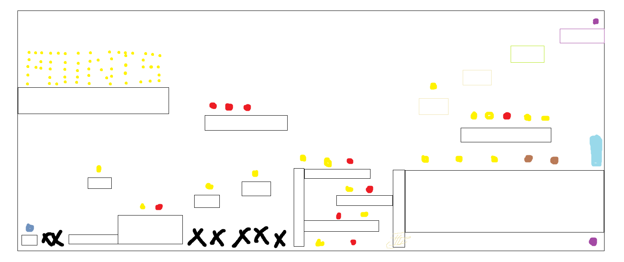

Yellow = gem / Red = Enemy / Purple = secret gems / Blue = finish line / Black = Death

1. **Screen Descriptions**

Starting the game

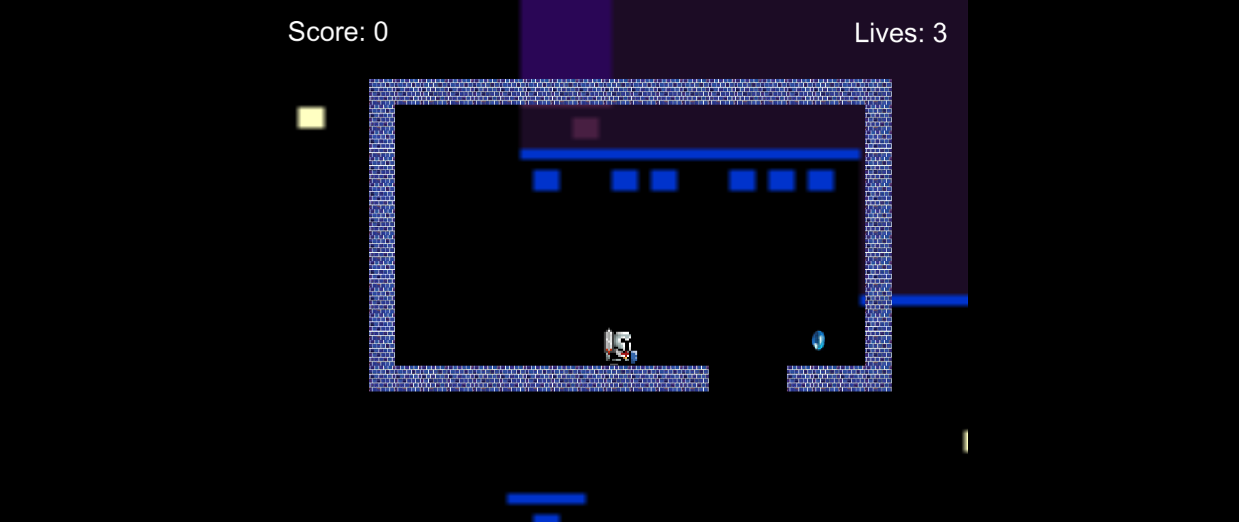

Gems and Idle Enemy

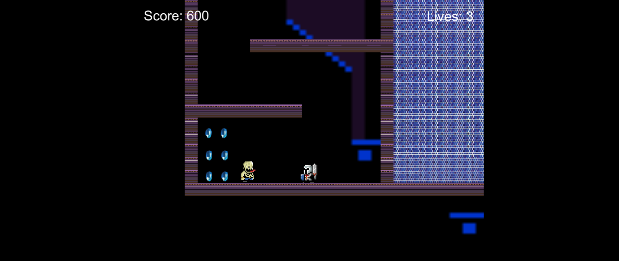

GameOver

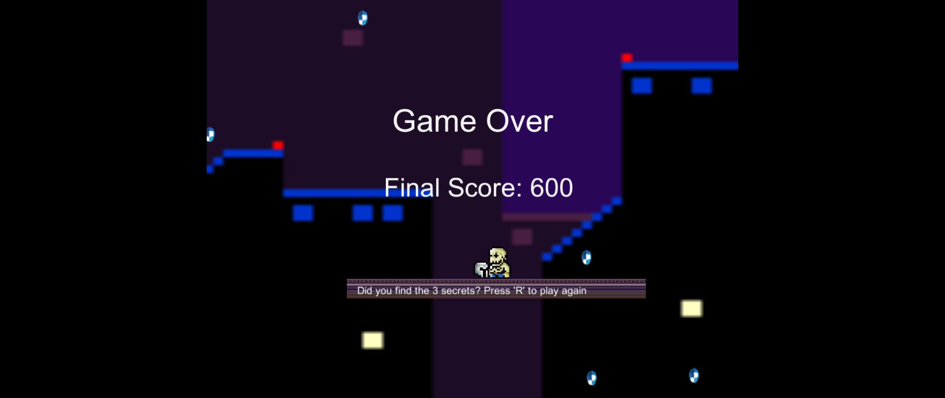

1. **Characters**

* Knight in silver armor holding a sword and shield
* 8-bit

1. **Enemies**

* Skeleton/monster wearing blue pants
* 8-bit

1. **Scoring**

* When player collides with blue crystal = 50 points
* When player collides with green crystal = 250 points
* When player collides with yellow crystal = 500 points
* When player collides with red crystal = 1000 points
* When player collides with enemy = lose 1 life
* When player collides with boundary (off map) = lose 3 life

1. **Bonuses**

* There are 3 secret gems to be found in the game, all giving different amount of points. Green crystal located on the left when player falls from start box. Yellow gem located on the right side of the “S” area (behind the wall as there is no colliders). Red crystal located on the top right corner of the map.

1. **Sound Index**

* Background music <http://opengameart.org/content/chaos-castle>
* Gem pick up – Coin 3 – Arcade SFX Free / Unity Asset Store
* Player jump –Bounce 8 – Arcade SFX Free / Unity Asset Store

1. **Art / Multimedia Index**

Main Character <https://www.assetstore.unity3d.com/en/?gclid=Cj0KEQjw4NmvBRCRp_yu2bzal4YBEiQAWfjpJmr8mRrLEnQ66wzQQykokNxHOvSjOIDWu08a764Ho4YaAhPu8P8HAQ#!/content/29304>

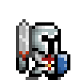

Enemy

<https://www.assetstore.unity3d.com/en/?gclid=Cj0KEQjw4NmvBRCRp_yu2bzal4YBEiQAWfjpJmr8mRrLEnQ66wzQQykokNxHOvSjOIDWu08a764Ho4YaAhPu8P8HAQ#!/content/27080>

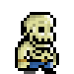

Background <http://phandroid.com/2015/07/25/android-8-bit-wallpaper/>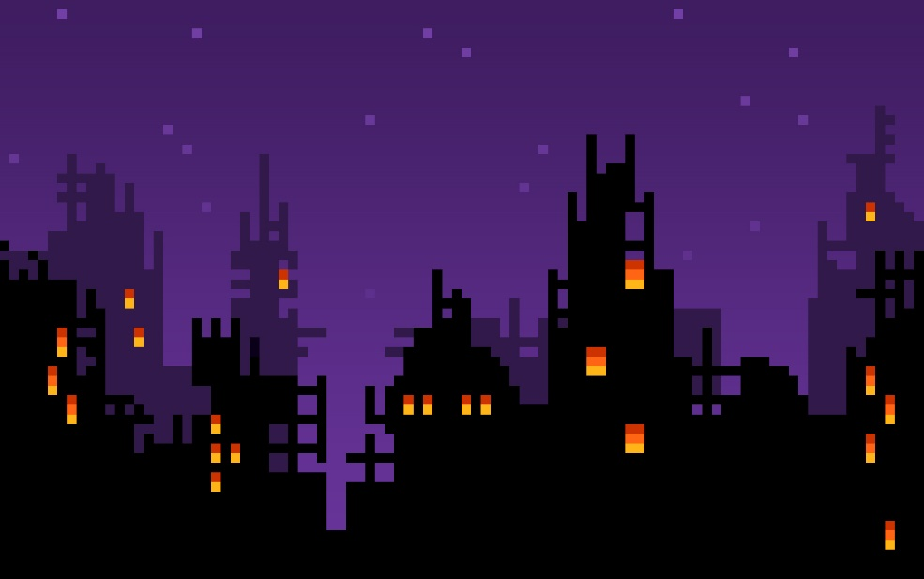

BridgeTiles

<https://www.assetstore.unity3d.com/en/?gclid=Cj0KEQjw4NmvBRCRp_yu2bzal4YBEiQAWfjpJmr8mRrLEnQ66wzQQykokNxHOvSjOIDWu08a764Ho4YaAhPu8P8HAQ#!/content/29304>

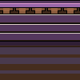

Purple brick Tile <http://www.pooltimepoolspa.com/pool_tile/>

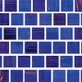

All Gems <http://opengameart.org/content/rotating-crystal-animation-8-step>

C:\Users\Jeff\AppData\Local\Microsoft\Windows\INetCache\Content.Word\crystal-qubodup-ccby3-16-green.png

C:\Users\Jeff\AppData\Local\Microsoft\Windows\INetCache\Content.Word\crystal-qubodup-ccby3-16-orange.png

C:\Users\Jeff\AppData\Local\Microsoft\Windows\INetCache\Content.Word\crystal-qubodup-ccby3-16-yellow.png

C:\Users\Jeff\AppData\Local\Microsoft\Windows\INetCache\Content.Word\crystal-qubodup-ccby3-16-grey.png

C:\Users\Jeff\AppData\Local\Microsoft\Windows\INetCache\Content.Word\crystal-qubodup-ccby3-16-blue.png